Nest Box
200mm
- Please use the following sizes as a guide. Use a plank about 140 mm wide.
Side
250mm
- The inside of the box must be at least 100 mm square and the bottom of the entrance hole must be at least 125 mm from the floor. If it is less, young birds might be scooped out by a cat.
Side
200mm
250mm
- Hinge the lid with a strip of leather or rubber (an old piece of bicycle inner tube would do). Do not nail the lid down.
- The entrance hole size (remember locate the hole 125mm from the bottom) depends on the type of bird you want to attract:
• 25 mm for coal tits, marsh tits and blue tits
• 28 mm for great tits and tree sparrows
• 32 mm for nuthatches and house sparrows
or
If you remove the top half of the front panel, the same type of box could attract robins, pied wagtails or wrens to nest. Spotted flycatchers prefer an even shallower, open-fronted box.
200mm
350mm
Base
Back
Lid
*140mm
*140mm
Front`
200mm
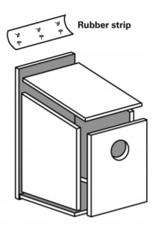
* Note the base is square, so if using a different width plank please adjust the base length.

